Name of the Student: G. Manasa | Academic Year: 2024 – 2028
Student Registration Number: 241U1R3007 | Year & Term: II & II
Study Level: UG | Class & Section: CSE – DS
Name of the Course: Java Programming | Name of the Instructor: Dr. A. Rajeshwar
Name of the Assessment: Lab Report - 7 | Date of Submission: 03-11-2025

Lab Report - 7
A. Basic Components
Input:
import javax.swing.*;
import java.awt.event.*;

public class LabelDemo {
public static void main(String[] args) {
JFrame f = new JFrame("JLabel Demo");
JLabel label = new JLabel("Click me!");
JLabel status = new JLabel("Status:");

label.addMouseListener(new MouseAdapter() {
public void mouseClicked(MouseEvent e) {
status.setText("Label clicked");
}
});

f.add(label, "North");
f.add(status, "South");
f.setSize(300, 200);
f.setVisible(true);
}
}

Output:
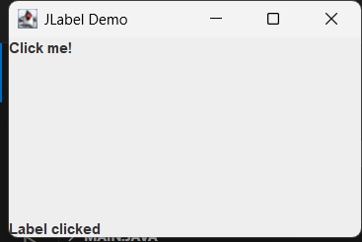

Input:
import javax.swing.*;
import java.awt.event.*;

public class ButtonDemo {
public static void main(String[] args) {
JFrame f = new JFrame("JButton Demo");
JButton btn = new JButton("Click Me");
JLabel status = new JLabel("Status:");

btn.addActionListener(e -> status.setText("Button clicked"));

f.add(btn, "North");
f.add(status, "South");
f.setSize(300, 200);
f.setVisible(true);
}
}
Output:
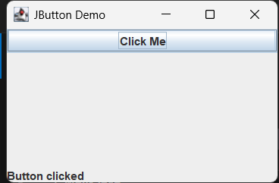

Input:
import javax.swing.*;
import java.awt.event.*;

public class ToggleDemo {
public static void main(String[] args) {
JFrame f = new JFrame("JToggleButton Demo");
JToggleButton toggle = new JToggleButton("OFF");
JLabel status = new JLabel("Status:");

toggle.addItemListener(e -> {
if (toggle.isSelected())
toggle.setText("ON");
else
toggle.setText("OFF");
status.setText("Toggled: " + toggle.isSelected());
});

f.add(toggle, "North");
f.add(status, "South");
f.setSize(300, 200);
f.setVisible(true);
}
}
Output:
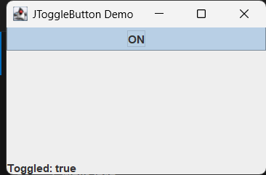

Input:
import javax.swing.*;
import java.awt.event.*;

public class CheckBoxDemo {
public static void main(String[] args) {
JFrame f = new JFrame("JCheckBox Demo");
JCheckBox cb = new JCheckBox("Accept?");
JLabel status = new JLabel("Status:");

cb.addItemListener(e ->
status.setText("Checked: " + cb.isSelected())
);

f.add(cb, "North");
f.add(status, "South");
f.setSize(300, 200);
f.setVisible(true);
}
}
Output:
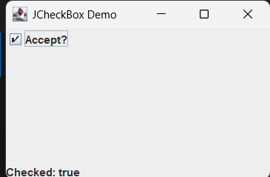
Input:
import javax.swing.*;
import java.awt.event.*;

public class RadioDemo {
public static void main(String[] args) {
JFrame f = new JFrame("JRadioButton Demo");
JRadioButton r1 = new JRadioButton("Male");
JRadioButton r2 = new JRadioButton("Female");
JLabel status = new JLabel("Status:");

ButtonGroup bg = new ButtonGroup();
bg.add(r1);
bg.add(r2);

r1.addActionListener(e -> status.setText("Selected: Male"));
r2.addActionListener(e -> status.setText("Selected: Female"));

JPanel p = new JPanel();
p.add(r1);
p.add(r2);

f.add(p, "North");
f.add(status, "South");
f.setSize(300, 200);
f.setVisible(true);
}
}
Output:
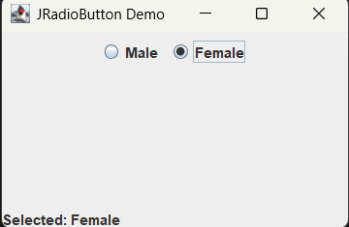

Input:
import javax.swing.*;

public class PasswordDemo {
public static void main(String[] args) {
JFrame f = new JFrame("JPasswordField Demo");
JPasswordField pf = new JPasswordField(15);
JLabel status = new JLabel("Status:");

pf.addActionListener(e ->
status.setText("Password length: " + pf.getPassword().length)
);

f.add(pf, "North");
f.add(status, "South");
f.setSize(300, 200);
f.setVisible(true);
}
}
Output:

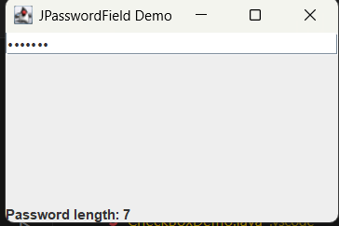

Input:
import javax.swing.*;
import javax.swing.event.*;

public class TextAreaDemo {
public static void main(String[] args) {
JFrame f = new JFrame("JTextArea Demo");
JTextArea ta = new JTextArea(5, 20);
JLabel status = new JLabel("Status:");

ta.getDocument().addDocumentListener(new DocumentListener() {
public void insertUpdate(DocumentEvent e) { status.setText("Typing..."); }
public void removeUpdate(DocumentEvent e) { status.setText("Removing..."); }
public void changedUpdate(DocumentEvent e) {}
});

f.add(new JScrollPane(ta), "Center");
f.add(status, "South");
f.setSize(350, 250);
f.setVisible(true);
}
}

Output:
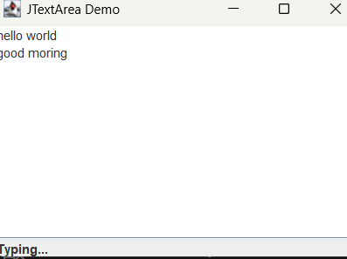

Input:
import javax.swing.*;
import java.text.*;

public class FormattedFieldDemo {
public static void main(String[] args) {
JFrame f = new JFrame("JFormattedTextField Demo");
JFormattedTextField ft = new JFormattedTextField(DateFormat.getDateInstance());
ft.setValue(new java.util.Date());
JLabel status = new JLabel("Status:");

ft.addActionListener(e ->
status.setText("Date: " + ft.getText())
);

f.add(ft, "North");
f.add(status, "South");
f.setSize(300, 200);
f.setVisible(true);
}
}
Output:
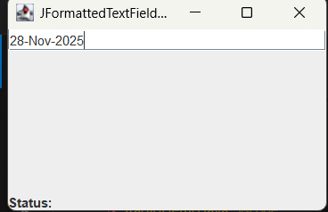

Input:
import javax.swing.*;

public class ComboDemo {
public static void main(String[] args) {
JFrame f = new JFrame("JComboBox Demo");
String[] items = {"Red", "Green", "Blue"};
JComboBox cb = new JComboBox(items);
JLabel status = new JLabel("Status:");

cb.addActionListener(e ->
status.setText("Selected: " + cb.getSelectedItem())
);

f.add(cb, "North");
f.add(status, "South");
f.setSize(300, 200);
f.setVisible(true);
}
}
Output:
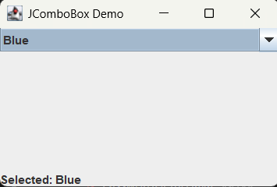

Input:
import javax.swing.*;

public class ListDemo {
public static void main(String[] args) {
JFrame f = new JFrame("JList Demo");
String[] data = {"Apple", "Banana", "Cherry"};
JList list = new JList(data);
JLabel status = new JLabel("Status:");

list.addListSelectionListener(e ->
status.setText("Selected: " + list.getSelectedValue())
);

f.add(new JScrollPane(list), "Center");
f.add(status, "South");
f.setSize(300, 250);
f.setVisible(true);
}
}
Output:
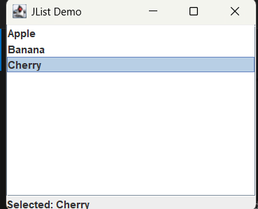

Input:
import javax.swing.*;

public class TableDemo {
public static void main(String[] args) {
JFrame f = new JFrame("JTable Demo");

String[] cols = {"ID", "Name"};
Object[][] data = {{1, "Manasa"}, {2, "Rahul"}};

JTable table = new JTable(data, cols);
JLabel status = new JLabel("Status:");

table.getSelectionModel().addListSelectionListener(e -> {
int row = table.getSelectedRow();
if (row >= 0)
status.setText("Selected: " + table.getValueAt(row, 1));
});

f.add(new JScrollPane(table), "Center");
f.add(status, "South");
f.setSize(400, 250);
f.setVisible(true);
}
}
Output:
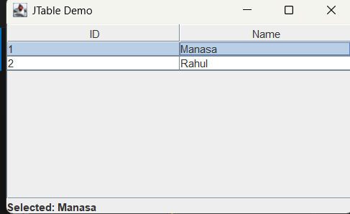

Input:
import javax.swing.*;
import javax.swing.tree.*;

public class TreeDemo {
public static void main(String[] args) {
JFrame f = new JFrame("JTree Demo");

DefaultMutableTreeNode root = new DefaultMutableTreeNode("Root");
root.add(new DefaultMutableTreeNode("Child 1"));
root.add(new DefaultMutableTreeNode("Child 2"));

JTree tree = new JTree(root);
JLabel status = new JLabel("Status:");

tree.addTreeSelectionListener(e ->
status.setText("Selected: " + tree.getLastSelectedPathComponent())
);

f.add(new JScrollPane(tree), "Center");
f.add(status, "South");
f.setSize(300, 300);
f.setVisible(true);
}
}

Output:
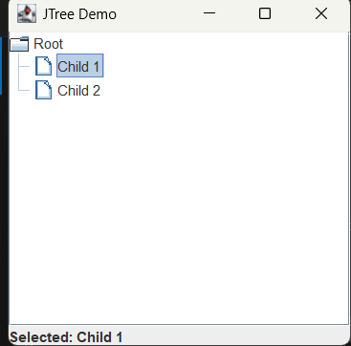

Input:
import javax.swing.*;
import javax.swing.event.*;

public class SliderDemo {
public static void main(String[] args) {
JFrame f = new JFrame("JSlider Demo");

JSlider slider = new JSlider(0, 100, 50);
JLabel status = new JLabel("Value: 50");

slider.addChangeListener(e ->
status.setText("Value: " + slider.getValue())
);

f.add(slider, "North");
f.add(status, "South");
f.setSize(300, 200);
f.setVisible(true);
}
}
Output:
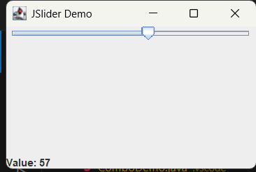

Input:
import javax.swing.*;

public class ProgressDemo {
public static void main(String[] args) {
JFrame f = new JFrame("JProgressBar Demo");

JProgressBar pb = new JProgressBar(0, 100);
JButton btn = new JButton("Start");

btn.addActionListener(e -> {
for (int i = 0; i <= 100; i += 10) {
pb.setValue(i);
try { Thread.sleep(200); } catch (Exception ex) {}
}
});

f.add(pb, "North");
f.add(btn, "South");
f.setSize(300, 200);
f.setVisible(true);
}
}
Output:
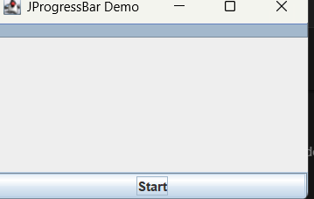

Input:
import javax.swing.*;

public class SpinnerDemo {
public static void main(String[] args) {
JFrame f = new JFrame("JSpinner Demo");

JSpinner sp = new JSpinner(new SpinnerNumberModel(1, 0, 10, 1));
JLabel status = new JLabel("Value: 1");

sp.addChangeListener(e ->
status.setText("Value: " + sp.getValue())
);

f.add(sp, "North");
f.add(status, "South");
f.setSize(300, 200);
f.setVisible(true);
}
}
Output:
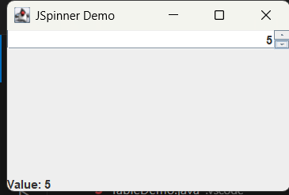

Input:
import javax.swing.*;
import javax.swing.event.*;

public class EditorPaneDemo {
public static void main(String[] args) {
JFrame f = new JFrame("JEditorPane Demo");

JEditorPane ep = new JEditorPane();
ep.setContentType("text/html");
ep.setText("<a href='https://example.com'>Click Me</a>");
ep.setEditable(false);

JLabel status = new JLabel("Status:");

ep.addHyperlinkListener(e -> {
if (e.getEventType() == HyperlinkEvent.EventType.ACTIVATED)
status.setText("Clicked link: " + e.getURL());
});

f.add(new JScrollPane(ep), "Center");
f.add(status, "South");
f.setSize(350, 250);
f.setVisible(true);
}
}
Output:

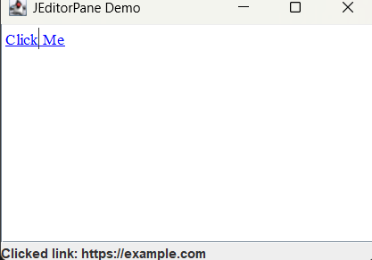
Input:
import javax.swing.*;
import javax.swing.event.*;
import javax.swing.text.*;

public class TextPaneDemo {
public static void main(String[] args) {
JFrame f = new JFrame("JTextPane Demo");

JTextPane tp = new JTextPane();
JLabel status = new JLabel("Status:");

tp.getDocument().addDocumentListener(new DocumentListener() {
public void insertUpdate(DocumentEvent e) { status.setText("Typing..."); }
public void removeUpdate(DocumentEvent e) { status.setText("Deleting..."); }
public void changedUpdate(DocumentEvent e) {}
});

JButton bold = new JButton("Bold");
bold.addActionListener(e -> {
StyledDocument doc = tp.getStyledDocument();
Style style = tp.addStyle("Bold", null);
StyleConstants.setBold(style, true);
doc.setCharacterAttributes(tp.getSelectionStart(),
tp.getSelectionEnd() - tp.getSelectionStart(), style, false);
});

f.add(new JScrollPane(tp), "Center");
f.add(bold, "North");
f.add(status, "South");
f.setSize(400, 300);
f.setVisible(true);
}
}
Output:

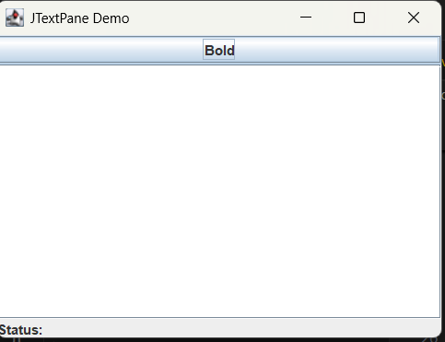

B. Containers & Panels
JPanel – Generic container
Input:
import javax.swing.*;
import java.awt.*;

public class JPanelDemo {
public static void main(String[] args) {
JFrame f = new JFrame("JPanel Demo");
JPanel panel = new JPanel();
JLabel status = new JLabel("Status: Click button");

JButton btn = new JButton("Click Me");
btn.addActionListener(e -> status.setText("Button clicked inside JPanel"));

panel.add(btn);

f.add(panel, BorderLayout.CENTER);
f.add(status, BorderLayout.SOUTH);
f.setSize(300, 200);
f.setVisible(true);
}
}
Output:
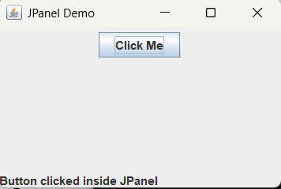

JScrollPane – Scrollable pane
Input:
import javax.swing.*;

public class JScrollPaneDemo {
public static void main(String[] args) {
JFrame f = new JFrame("JScrollPane Demo");

JTextArea area = new JTextArea(10, 30);
area.setText("Type here...\nScroll down...");

JScrollPane sp = new JScrollPane(area);

f.add(sp);
f.setSize(300, 250);
f.setVisible(true);
}
}
Output:
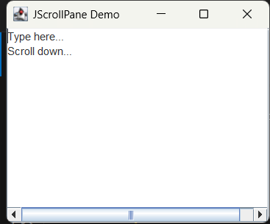

C. MENUS
JMenuBar + JMenu + JMenuItem
Input:
import javax.swing.*;
import java.awt.event.*;

public class MenuDemo {
public static void main(String[] args) {
JFrame f = new JFrame("Menu Demo");
JLabel status = new JLabel("Status: Choose menu item");

JMenuBar menuBar = new JMenuBar();
JMenu fileMenu = new JMenu("File");
JMenuItem openItem = new JMenuItem("Open");
JMenuItem exitItem = new JMenuItem("Exit");

openItem.addActionListener(e -> status.setText("Open clicked"));
exitItem.addActionListener(e -> System.exit(0));

fileMenu.add(openItem);
fileMenu.add(exitItem);
menuBar.add(fileMenu);

f.setJMenuBar(menuBar);
f.add(status);

f.setSize(300, 200);
f.setVisible(true);
}
}
Output:
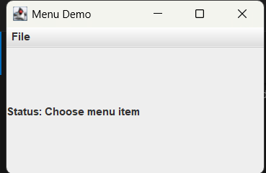

D. DIALOG COMPONENTS
JDialog – Custom Dialog
Input:
import javax.swing.*;
import java.awt.*;

public class JDialogDemo {
public static void main(String[] args) {
JFrame f = new JFrame("JDialog Demo");
JButton btn = new JButton("Open Dialog");

btn.addActionListener(e -> {
JDialog dialog = new JDialog(f, "My Dialog", true);
dialog.setSize(200, 150);
dialog.add(new JLabel("This is a dialog!", SwingConstants.CENTER));
dialog.setLocationRelativeTo(f);
dialog.setVisible(true);
});

f.add(btn);
f.setSize(300, 200);
f.setVisible(true);
}
}
Output:
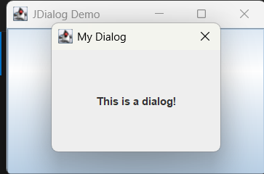

JFileChooser – File Picker
Input:
import javax.swing.*;
import java.io.File;

public class JFileChooserDemo {
public static void main(String[] args) {
JFrame f = new JFrame("JFileChooser Demo");
JButton btn = new JButton("Choose File");

btn.addActionListener(e -> {
JFileChooser fileChooser = new JFileChooser();
int result = fileChooser.showOpenDialog(f);

if (result == JFileChooser.APPROVE_OPTION) {
File selected = fileChooser.getSelectedFile();
JOptionPane.showMessageDialog(f, "Selected: " + selected.getAbsolutePath());
}
});

f.add(btn);
f.setSize(300, 200);
f.setVisible(true);
}
}
Output:
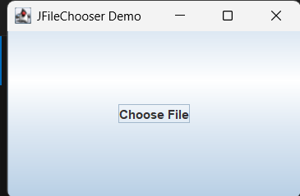
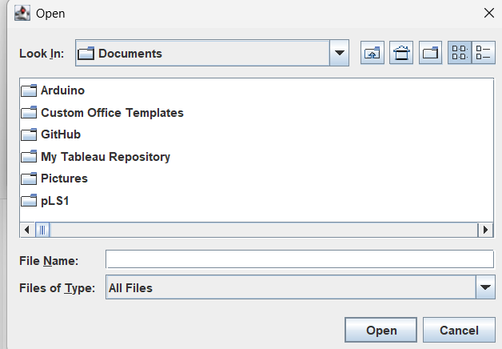
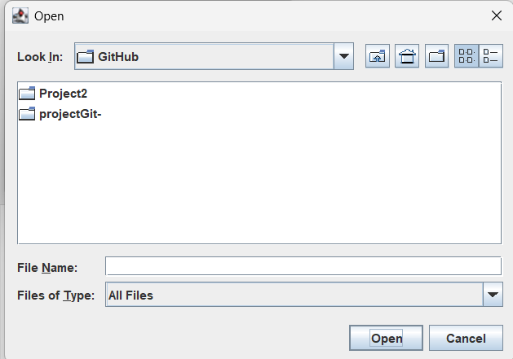
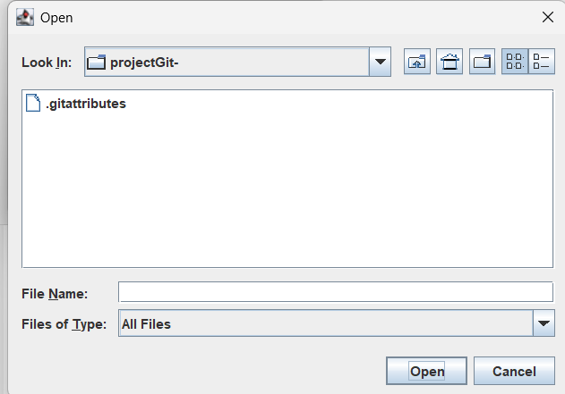
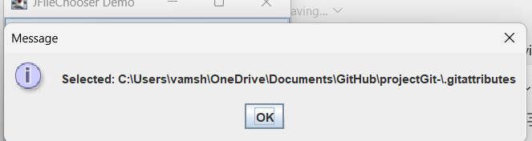

JColorChooser – Color Picker
Input:
import javax.swing.*;
import java.awt.*;

public class JColorChooserDemo {
public static void main(String[] args) {
JFrame f = new JFrame("JColorChooser Demo");
JButton btn = new JButton("Pick Color");
JPanel panel = new JPanel();

btn.addActionListener(e -> {
Color c = JColorChooser.showDialog(f, "Choose a Color", Color.WHITE);
if (c != null) panel.setBackground(c);
});

f.add(btn, "North");
f.add(panel, "Center");

f.setSize(300, 250);
f.setVisible(true);
}
}
Output:
